Cortex Code HOL Guide - Exercise 1

- From the Home Page, click Projects > Workspaces
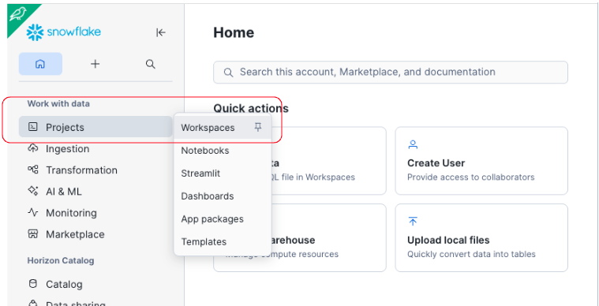

- Click on the Workspace name:
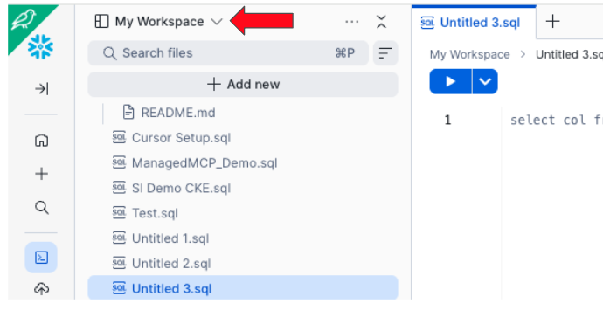

- Click Create > Private Workspace

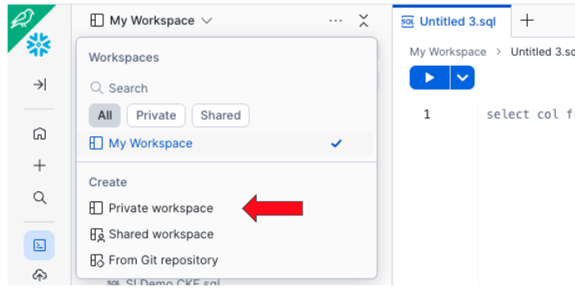

- Give a name to the new private workspace. Here it’s called ‘Coco_HOL’

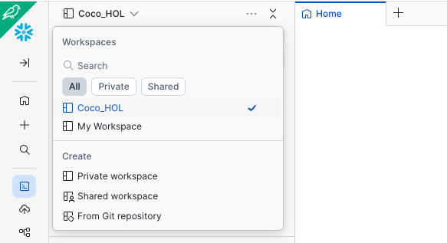

- Click on: Add New > Upload Folder. And select the Parent folder you extracted from the zipped file

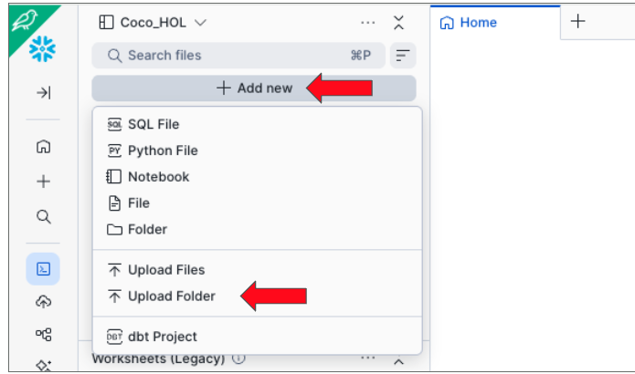

- After you upload the parent folder, you should see the folders reflected in the dropdown.
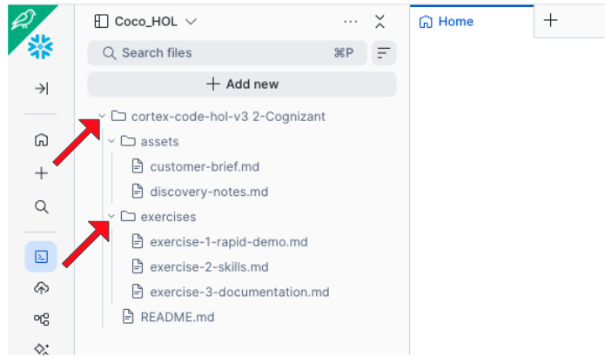

- Double click on the exercise-1-rapid-demo.md file and you should see it open up as a worksheet in the workspace. Now click on the Cortex Code icon on the bottom right
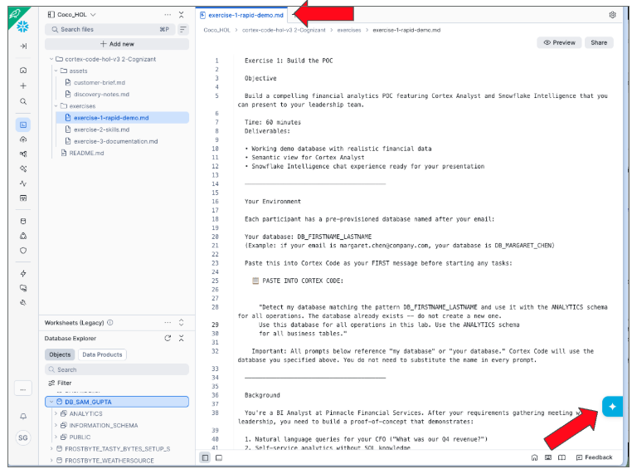

- You will see the Coco conversation interface open up. That’s where you can prompt Cortex Code with instructions. For example, below is the first prompt given to Coco as described in the exercise-1-rapid-demo file.

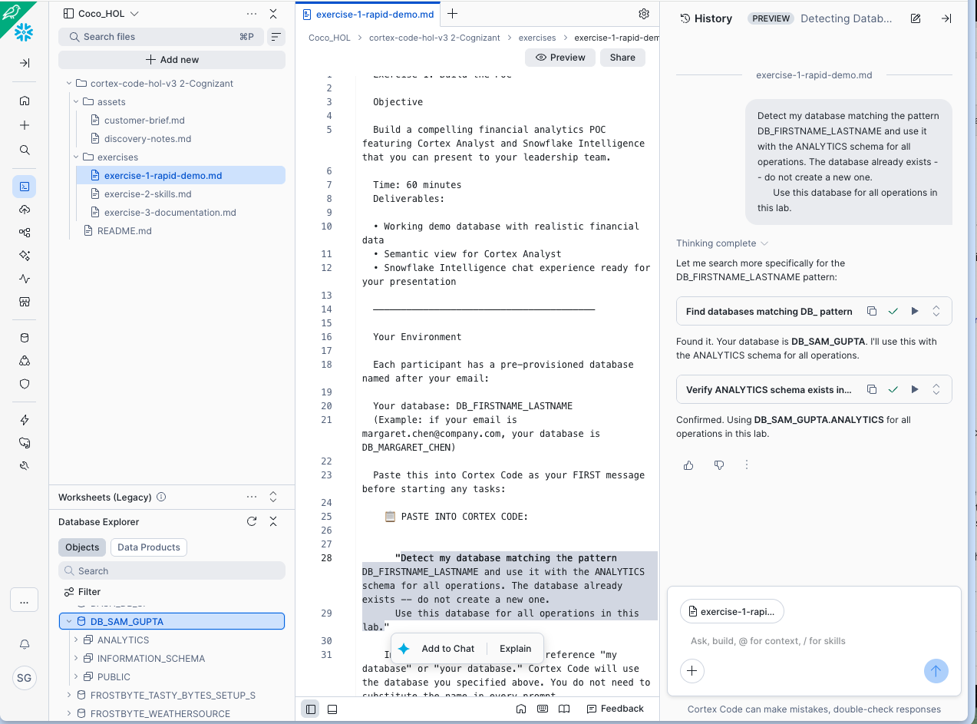

- Continue following the instructions in the first exercise and complete Exercise 1.
- After completing all the prompts in Exercise 1, let’s verify that your agent is created. Click on AI&ML > Agents
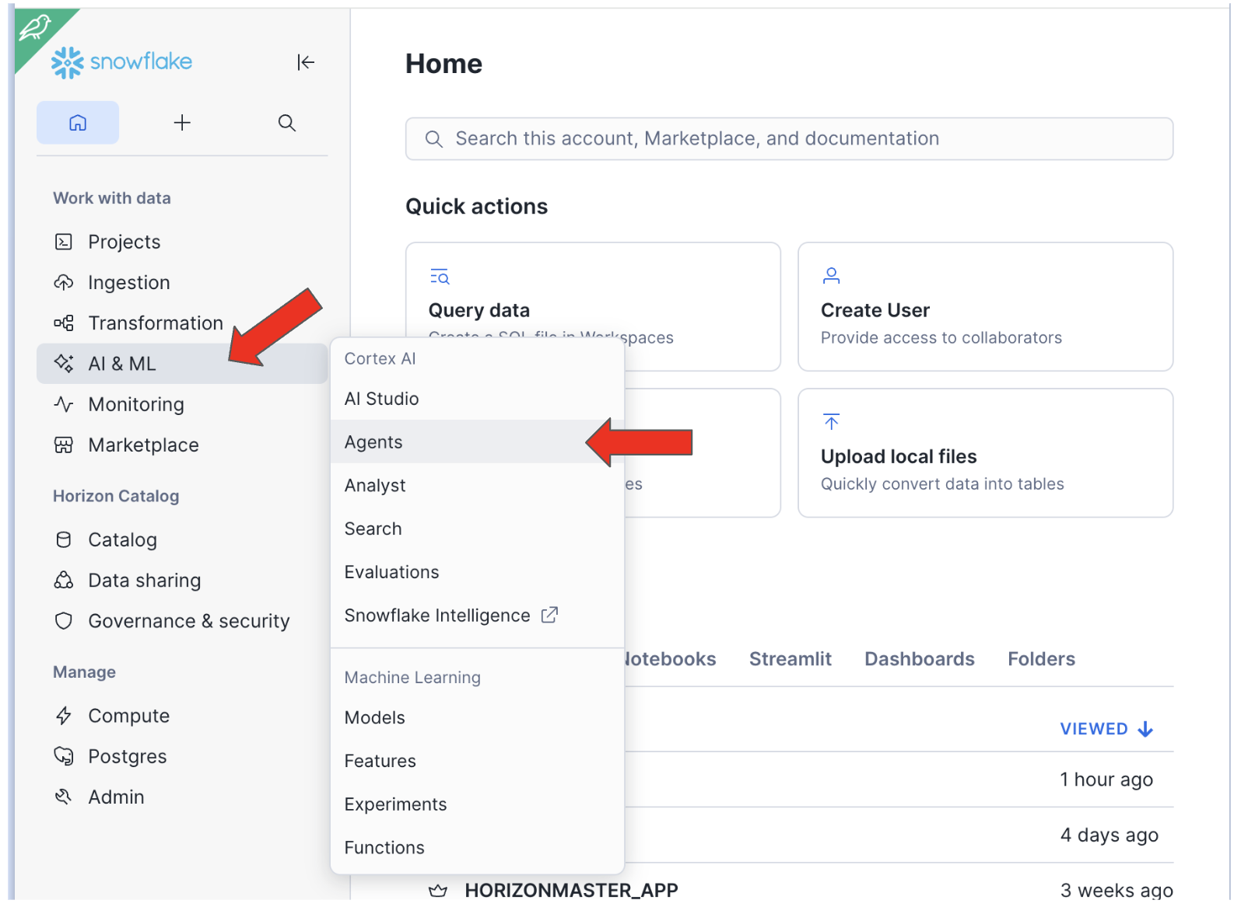

- You should see your Cortex Agent listed. Click on the ‘PINNACLE_FINANCIAL_ANALYST’ agent. You should now be able to start asking questions to the agent you created, congratulations!
